CACFP Application Walkthrough and Q&A
For 2023-2024
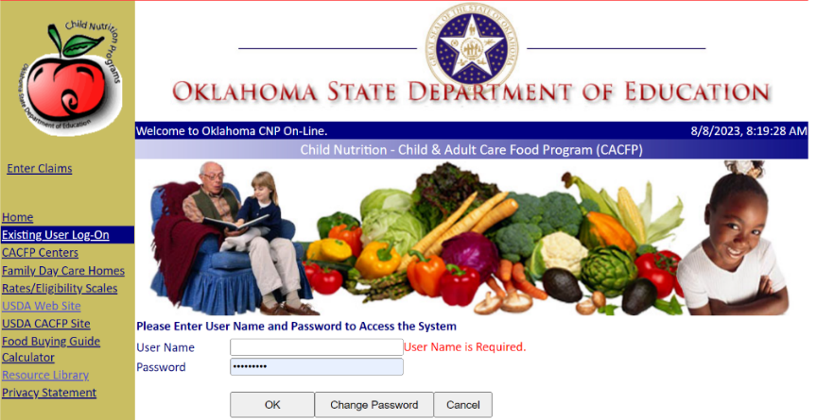

Description:
This is a walkthrough is for ALL programs on how to fill out the application. There are not any major changes to the application for FY2024

Who is this for? Anyone who fills out the CACFP online Application & Agreement. This is not program specific

Dates & Times offered:
- Tuesday, December 5th at 9:00 am
- Tuesday, January 2nd at 9:00 am
- Tuesday, February 6th at 9:00 am
- Tuesday, March 5th at 9:00 am
- Tuesday, April 2nd at 9:00 am
- Tuesday, May 7th at 9:00 am
- Tuesday, June 4th at 9:00 am
- Tuesday, July 2nd at 9:00 am

Link to Register:
Register in advance for this meeting (use the drop-down box to select the date):
Right click on the link and select open hyperlink or copy and paste the link into your internet browser
https://www.zoomgov.com/meeting/register/vJIsdO6oqDsuHkdcXiV9WLRz5EV2nWO3DQQ

*There is no credit for going to this walkthrough. Application Walkthrough and Q&A is not located in the Training Calendar.

